<ADD YOUR LOGO HERE>

CAMPAIGN BRIEF FOR PARTICIPATING INFLUENCERS
_____________________________________________________________________

Brand: ADVERTISER
Campaign Title: Net Worth Calculation
Start Day: DATE
End Date: DATE
Campaign Objectives: Open more checking accounts and gain new members.

BRAND BIO
ADVERTISER was founded in 1951 to serve the financial needs of CITY municipal employees. Today, with more than 116,000 members and assets in excess of $1 billion, ADVERTISER is among the top ten credit unions in the area, serving the owners, employees and directors of more than 400 organizations throughout Pennsylvania, New Jersey and Delaware. Their mission is to provide for the financial well-being of their membership through a dedicated and unique combination of professional and personal service. As a member-owned institution, they will invest daily in building one-on-one relationships with their membership community through uncompromising service, convenience and a complete offering of competitive financial products and services.

Since their very first day, ADVERTISER has helped ordinary consumer achieve their goals. They have helped them open businesses, and educate their kids. They’ve helped teach them about how to handle their money better, and how to save for the future. And it remains their continued ambition to become the leading credit union in the Delaware Valley, in recognition of ADVERTISER’s commitment to their ownership and as stewards of their financial independence.

BRAND Website: https://www.ADVERTISER.com/

Campaign Objectives: To cultivate ADVERTISER awareness, drive prospective customers to a specific ADVERTISER landing page, and encourage prospects to open a checking account.

DETAILED CAMPAIGN GUIDELINES
Phase 1: Sources for Information Gathering
The influencers are asked to promote ADVERTISER’s website by guiding followers to discover their net worth and tips on how to improve it with ADVERTISER Bank. To gain more information on this topic go to the ADVERTISER website and look at the financial education web page: https://www.ADVERTISER.com/financial-education. The influencer should also discover things which are unique about ADVERTISER and find out about the checking accounts offered.

Images of how to get to the Net Worth landing Page:
Link: https://www.ADVERTISER.com/financial-education/financial-calculators

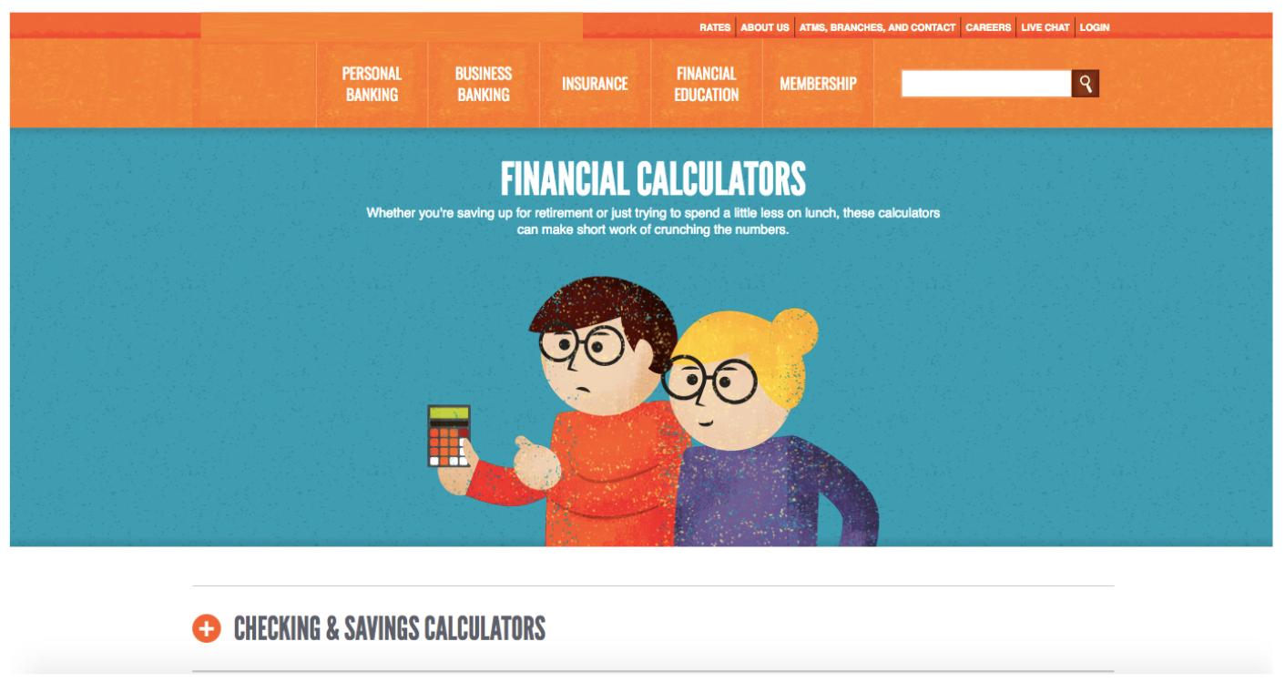

Click on Checking and Saving Calculators, Then you will see the Net Worth Calculator:
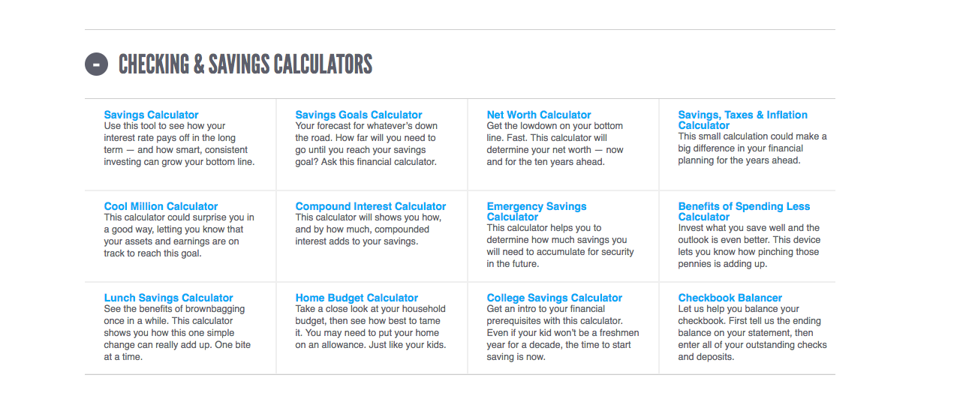

The Page will look like this:

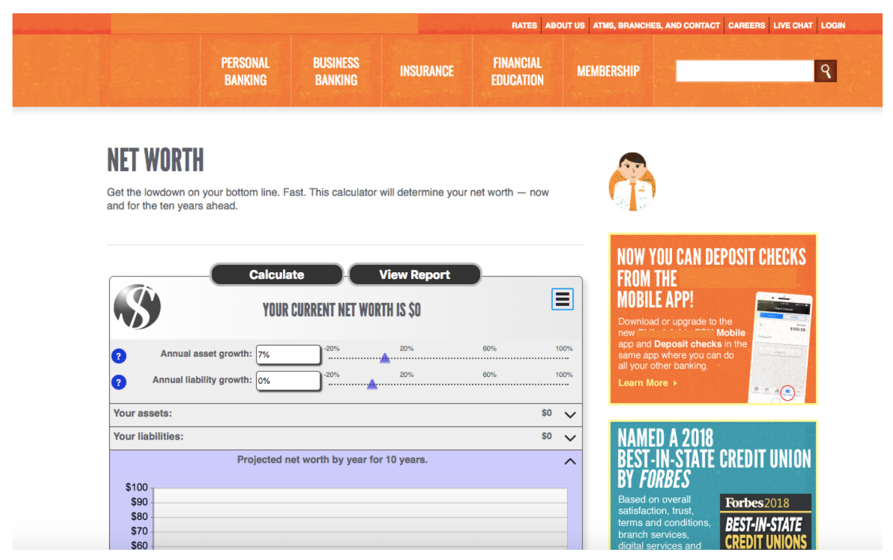

Phase 2: Publication Guidelines
Each influencer will be required to create and share one of the following:
- ONE BLOG POST -
  - Publication Deadline: DATE
  - Publication details for a blog post: One dedicated blog post which describes what they learned during phase 1. The blog post should be a minimum of 500 words, include five influencer-generated images, and include a call-to-action (CTA) to drive readers to the ADVERTISER checking account landing page. This CTA should be repeated at least three times. Unique tracking links will be provided by email to each influencer. Discuss what you think is unique about ADVERTISER and focus on checking account options and features.
  - Furthermore, influencers should share a link for a raffle to win a $200 gift card in their blog post. To be entered, readers have to share the blog post with at least three other people. Information about the raffle should be positioned towards the beginning of the blog post. The specific URL for this raffle will be sent to the influencers by ADVERTISER/AGENCY. The raffle will be managed by Rafflecopter.com.
  - Influencers must ensure all content is compliant with FTC guidelines by including a statement at the beginning of their post writing “This post has been sponsored by ADVERTISER and ADVERTISER/AGENCY; all opinions are entirely my own.”
  - After posting, influencers must send the link to the blog to ADVERTISER/AGENCY, who will create a trackable link to include in social posts.

- ONE YOUTUBE VIDEO -
  - Publication Deadline: January 31, 2019
  - Publication Details: One dedicated youtube video which explains what they learned from Phase 1. The video should be a minimum of one minute and include a call-to-action (CTA) to drive viewers to the ADVERTISER checking account landing page. This CTA should be in the description and be positioned as an overlay. Unique tracking links will be provided by email to each influencer. Discuss your consultation experience, what you have learned, and focus on checking account options and features.
  - Furthermore, influencers should share a link for a raffle to win a $200 gift card in the description. To be entered, readers have to share the video with at least three other people. Information about the raffle should be positioned towards the beginning of the video. The specific URL for this raffle will be sent to the influencers by ADVERTISER/AGENCY. The raffle will be managed by Rafflecopter.com.
  - Influencers must ensure all content is compliant with FTC guidelines by including this statement (or similar): “This post has been sponsored by ADVERTISER and ADVERTISER/AGENCY; all opinions are entirely my own.”
  - After posting, influencers must send the link to the video to ADVERTISER/AGENCY, who will create a trackable link to include in social posts.

Each influencer will be required to create and share each of the following:

- ONE INSTAGRAM POST -
  - Publication Deadline: Within two days of publication of blogpost or youtube video
  - Publication Details: Influencers should use a picture of themselves taken during information gathering in Phase 1. The CTA in this post should drive followers to the blog post or youtube video and mention the raffle. A trackable link to the blog post or youtube video will be sent to the influencers by ADVERTISER/AGENCY, and should remain in the influencers’ bios for 24 hours. The link should be mentioned in the description of the post. The post should also include the hashtag #insideADVERTISER. Influencers must ensure all content is compliant with FTC guidelines by including the hashtag #ad.

- ONE INSTAGRAM STORY -
  - Publication Deadline: Within two days of publication of blogpost or youtube video
  - Publication Details: Influencers should use a picture of themselves taken during information gathering in Phase 1. The CTA in this post should drive followers to the blog post or youtube video and mention the raffle. A trackable link to the blog post or youtube video will be sent to the influencers by ADVERTISER/AGENCY, and should be included in the post as a swipe-up feature. The post should also include the hashtag #insideADVERTISER. Influencers must ensure all content is compliant with FTC guidelines by including the hashtag #ad.

- ONE FACEBOOK POST -
  - Publication Deadline: Within two days of publication of blogpost or youtube video
  - Publication Details: Influencers should use a picture of themselves taken during information gathering in Phase 1. The CTA in this post should drive followers to the blog post or youtube video and mention the raffle. A trackable link to the blog post or youtube video will be sent to the influencers by ADVERTISER/AGENCY, and should be included in the post. The post should also include the hashtag #insideADVERTISER. Influencers must ensure all content is compliant with FTC guidelines by including the hashtag #ad.

REVIEW PROCEDURE
We understand and value influencers’ creativity and user-generated content, and it is not our intention to alter your unique voice. That said, banks follow strict compliance guidelines. For this reason, the client’s compliance department needs to check that all content meets bank regulations. Influencers will submit their content to ADVERTISER/AGENCY’s campaign manager, and the campaign manager will submit the content to ADVERTISER’s compliance department. No content should be posted without adhering to this procedure. If changes are necessary, influencers reserve the right to opt out of the campaign. We want to ensure that all posts maintain each influencer’s unique voice.

DISCLAIMER
ADVERTISER and ADVERTISER/AGENCY reserve the right to use any content from this campaign for any other promotional use.

